6 Way Horizontally Mounted Rackmount Schuko Plug PDU - 16A Schuko Sockets (PDU-6WS-H-SCH-SCH)

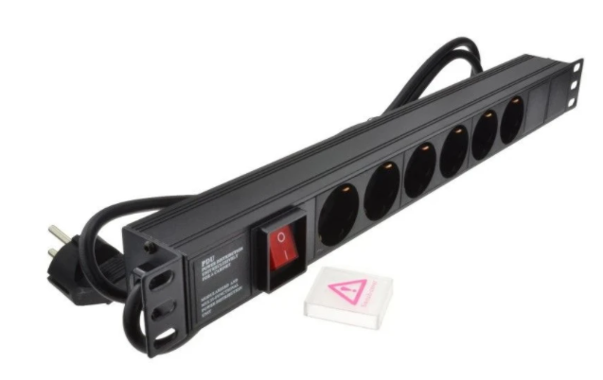

Description:
The LMS Power PDU-6WS-H-SCH-SCH is a high-quality horizontally mounted PDU (Power Distribution Unit) that simply fits within the universal mounting brackets of data, telecom and server cabinets.
A must-have accessory for your data cabinets if you need to provide effective power to devices including Ethernet Switches, Servers, UPS, NAS and of course cabinet accessories including cooling fan trays.
Robust, alloy design complete with rackmount brackets fitted, high-quality Neon Switch, high-load standardised 16 A rated Schuko power input plug connected to Schuko output power sockets.

Key Features:
Standard Schuko power outlets for your appliances
Standardised Schuko 16 Amp power plug
1U horizontally mounted attaches to internal profiles
Neon On/Off Rocker switch to prevent accidental turn off
Backed up by LMS Power's exclusive 3-year warranty

Applications:
Create instant power feeds to your data, telecom or server cabinets
Provide effective power for cabinet cooling fans, UPS systems
Ideal as stand-alone trailing sockets outside the cabinet

Product Code:
Part Number: PDU-6WS-H-SCH-SCH
EAN: 8400800033253
Weight: 1.7Kg approx

Technical Specifications:
Warranty LMS Data 3-Year Warranty
Chassis 1U horizontally PDU with mounting brackets
Output Sockets 6 Schuko Sockets
Power Input Standardised Schuko Plug
Flex Length 1.8 metres (approx)
Power Control On/Off Rocker Switch (illuminated)
Power Rating 4000 Watts (approx) Surge Protected

Supplied With:
PDU-12WS-H-IEC-IEC20 6 Way Horizontal PDU
Cabinet brackets (Fitted)
* Specifications and product design are subject to change. E&OE.

Looking for highperformance power distribution using the industry standard Schuko(tm) fitment? The newly developed LMS Data 16A heavy-duty horizontal, rack-mount PDU is ideal for high-loading device requirements including server, network and other industrial-type equipment functions such as broadcast and HVAC applications, plus ideal for EU/European AC power applications. Combining a fully certified Schuko(tm) 16A plug input combined with a compatible heavy load power flex means you can be assured this LMS Data PDU can work without problems, 24/7. Furthermore, incorporated onto the horizontal form-factor is standard Schuko(tm) sockets, 6 in total, allowing for safe and secure electrical power feeds to your high power appliances and devices. Robust in design, with an integral neon illuminated rocker switch for assured functionality, the LMS Data PDU is designed to deliver maximum electrical power today and tomorrow

specifications:
Horizontal high-performance Power Distribution Unit
Industry standard Schuko(tm) power outlets (6 outlets)
Industry-standard Schuko(tm) male EU fitted plug
Robust, black aluminium design for industrial use
Neon on/off power switch for assured control and safety
1.8 metre (approx.) power cordage
Ideal for data, telecom, broadcast and HVAC applications

